**Ideation Phase**

**Empathize & Discover**

|  |  |
| --- | --- |
| Date | 20 May 2023 |
| Team ID | NM2023TMID13273 |
| Project Name | The Future of Work:Data Analysis of Glassdoor Job |
| Maximum Marks | 4 Marks |

**Empathy Map Canvas:**

An empathy map is a simple, easy-to-digest visual that captures knowledge about a user’s behaviours and attitudes.

Thinking: As a user, I want an intelligent garbage classification system to accurately identify different types of garbage, enabling proper disposal and environmental sustainability.

Feeling: I feel frustrated with the current lack of efficient garbage sorting methods, and I desire a solution that simplifies the process and reduces waste pollution.

Hearing: I have heard about deep learning and its potential in image recognition tasks, leading me to believe that it can be applied to garbage classification as well.

Seeing: I have observed the growing concern for environmental issues and the need for innovative technologies to address waste management challenges effectively.

Saying/Doing: I am actively searching for an intelligent garbage classification solution that utilizes deep learning algorithms, and I am willing to adopt and support such a system to contribute to a cleaner and greener future.

**Example:**

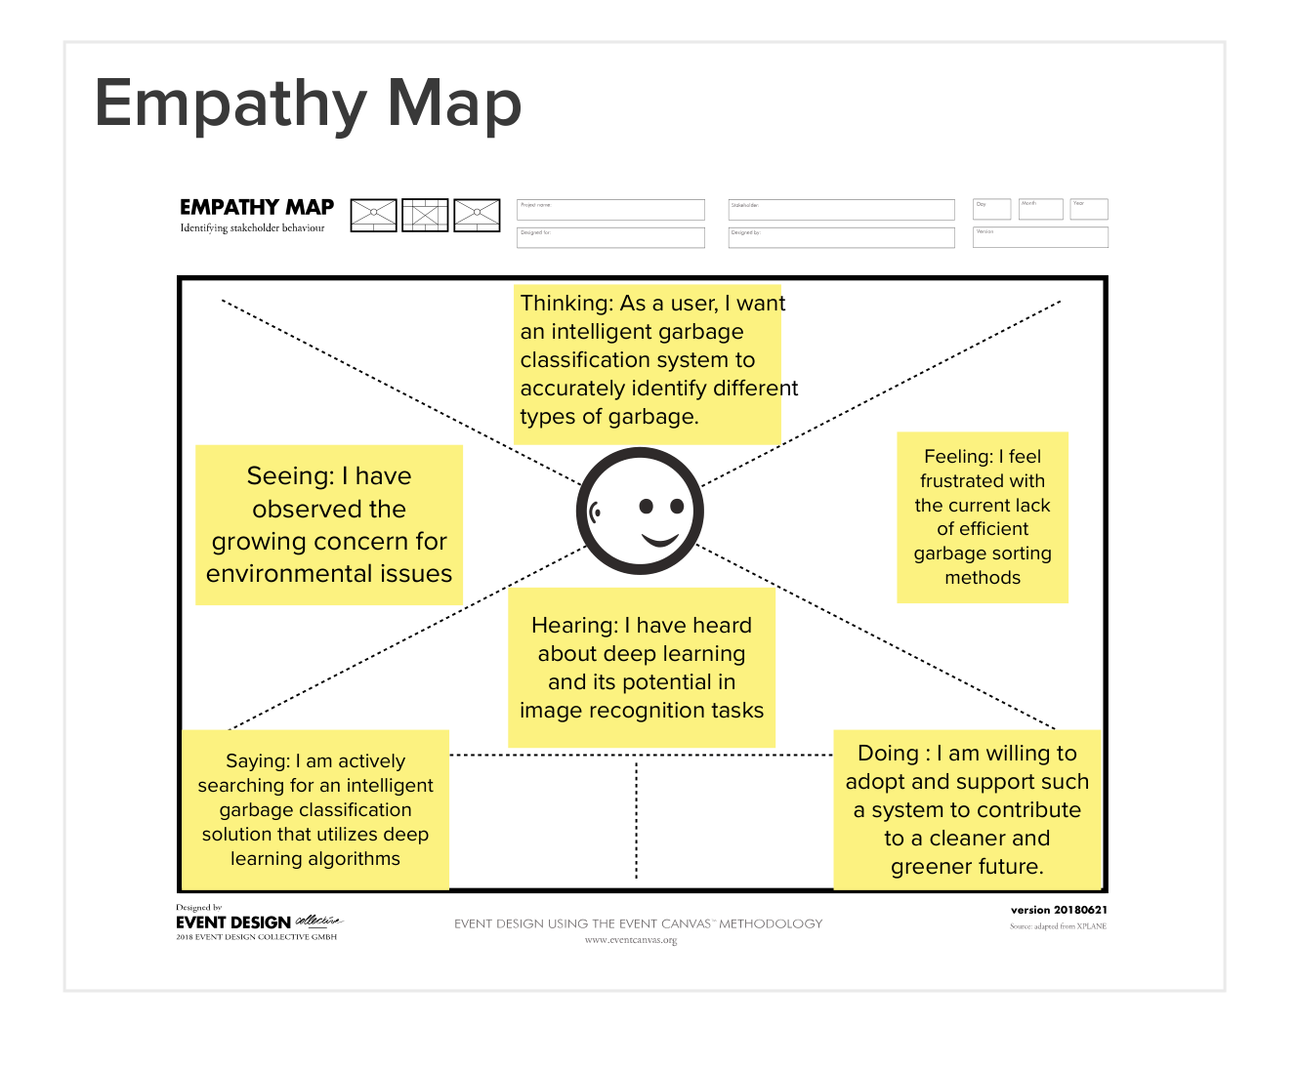

**Example: Intelligent Garbage Classification Using Deep Learning**

